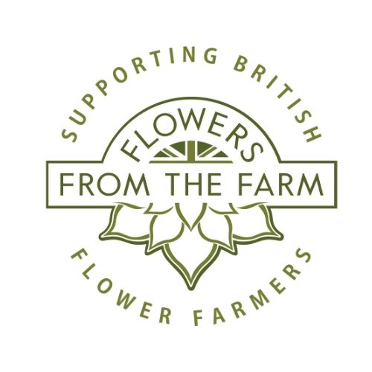

Flowers form the Farm

Virtual AGM

Monday 31 Jan 2022. 7PM - CHAIR, Carole Patilla.

1. WELCOME & INTRODUCTIONS
- Carole Patilla (Tuckshop Flowers), outgoing Co-chair.
- Meg Edmonds Co-chair (continuing)
- Incoming Co-chair Debbie Scott (East Lothian Flower Farm)
- Confirmation of quorum.
- Welcome from Carole

2. APOLOGIES FOR ABSENCE
3. APPROVAL OF MINUTES OF THE PREVIOUS ANNUAL GENERAL MEETING
4. REPORTS:
- Chair (Inc Summary of Regional Information)
- Membership
- Website
- PR
- Diversity Action Group
5. FINANCIAL REPORTS AND APPROVAL OF ACCOUNTS
6. FUTURE PLANS
7. ELECTION OF FTTF TEAM
8. APPOINTMENT OF DIRECTORS
9. ANY OTHER BUSINESS
Any items for consideration as AOB should be submitted to adminsupport@flowersfromthefarm.co.uk before 31st December 2020.

