MEDIA RELEASE
for immediate release

***TEMPLATE: PLEASE RE-WRITE (pink areas especially) WITH YOUR OWN MESSAGE AND EVENT DETAILS. MAX 2 PAGES***

Blooming British Blooms! Exeter flower farmer to open gates to visitors on Sunday, 7th August for the Flower Farmers’ Big Weekend. #FlowerFarmersBigWeekend
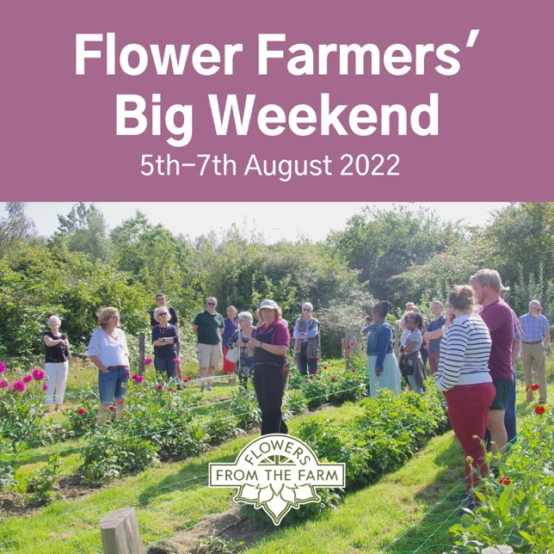
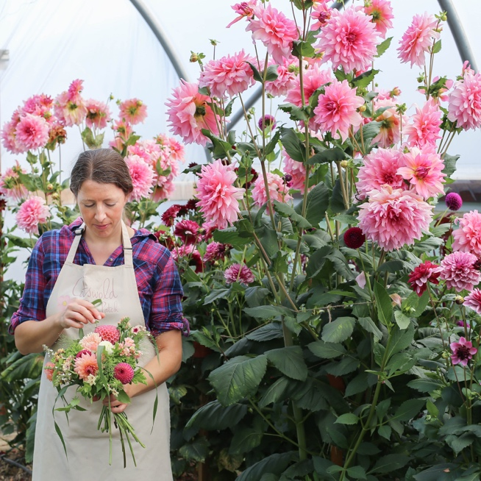
REPLACE WITH YOUR OWN IMAGE
Connie Cornflower of Blooming Brilliant in Exeter is opening the gates to her working flower farm to the public on Sunday, 7th August as part of the Flower Farmers’ Big Weekend, organised by Flowers from the Farm, the award-winning membership association championing over artisan cut flower growers. The nationwide open flower farm festival (5th-7th August) is a chance for flower-lovers to discover their local flower farms, talk to the growers and learn more about the art, craft, and business of growing local, seasonal, scented British cut flowers.

Connie started growing cut flowers on her allotment in the village of Lower Exeter five years ago after a career in nursing and has quickly developed a blooming business supplying fresh and dried flowers for local weddings, events, funerals and gift bouquets. “The support from the local community for our flower farm has been incredible,” says Connie. “People are so much more aware now that locally-grown, seasonal flowers are not only the most sustainable flowers that money can buy, but they are also the most beautiful.”

Visitors to Connie’s allotment in the village of Lower Exeter will be able to soak in the sight and scent of rows of flowers in bud and bloom, ask questions of the grower, and buy flowers freshly picked from the plot to take home. Weather permitting, you can expect to see late summer favourites such as the scene-stealing dahlias, lilies, scented phlox, stocks, nicotiana, roses, vibrant zinnias, sunflowers, larkspur, agapanthus, echinops, kniphofia, cornflower, nigella, asters, snapdragons, asters, cosmos, hydrangea, sedums and trailing amaranthus.

MORE ABOUT WHAT THERE IS TO SEE AND DO, AND WHAT YOU DO, CHARITY PARTNERS WHERE APPROPRIATE, WHY PEOPLE LOVE YOUR FLOWERS etc…

How to Book: Advance booking to the Blooming Brilliant event is essential. To book tickets, visit www.bloomingbrilliant.co.uk or call Connie Cornflower on XXXXXX.

About Flowers from the Farm www.flowersfromthefarm.co.uk #britishflowers

Founded in 2011, Flowers from the Farm is a not-for-profit membership association championing nearly 1000 artisan growers of local, seasonal, scented British cut flowers from the Isle of Skye to the Isles of Scilly. Flowers from the Farm aims to encourage more people to grow cut flowers for market in Britain; promote British flowers; and foster friendship and sharing through meetings, activities, and communication. Members offer seasonal, garden-style, scented blooms fresh from the plot, and the most sustainable flowers that money can buy. Search for your local flower farmer at www.flowersfromthefarm.co.uk.

Media Contact www.bloomingbrilliant.co.uk

For hi-res images, interviews, feature stories and further information on Blooming Brilliant, contact:

Connie Cornflower, Blooming Brilliant
M:
T:
E:

