British Flowers Week toolkit
Join us in celebrating British Flowers Week 2026, 15–21 June, a national celebration of the British floral industry from flower farmers through to florists.

British Flowers Week is a platform for connections to flourish, for customers to be inspired and for knowledge to be shared across the industry and beyond. Its aims are:

- showcasing how British flowers can inspire and delight amongst the trade and end customers;

- celebrating the role of women in the industry;

- highlighting the important economic and biodiversity contribution of flower farming.
Social media
We want to get as many people as possible to celebrate British flowers across the media in the weeks leading up to and including British Flowers Week.

To coordinate our impact for the biggest effect, we’re encouraging all members to post on 1 June 2026 – announcing their plans and support of #BritishFlowersWeek2026.

Example:

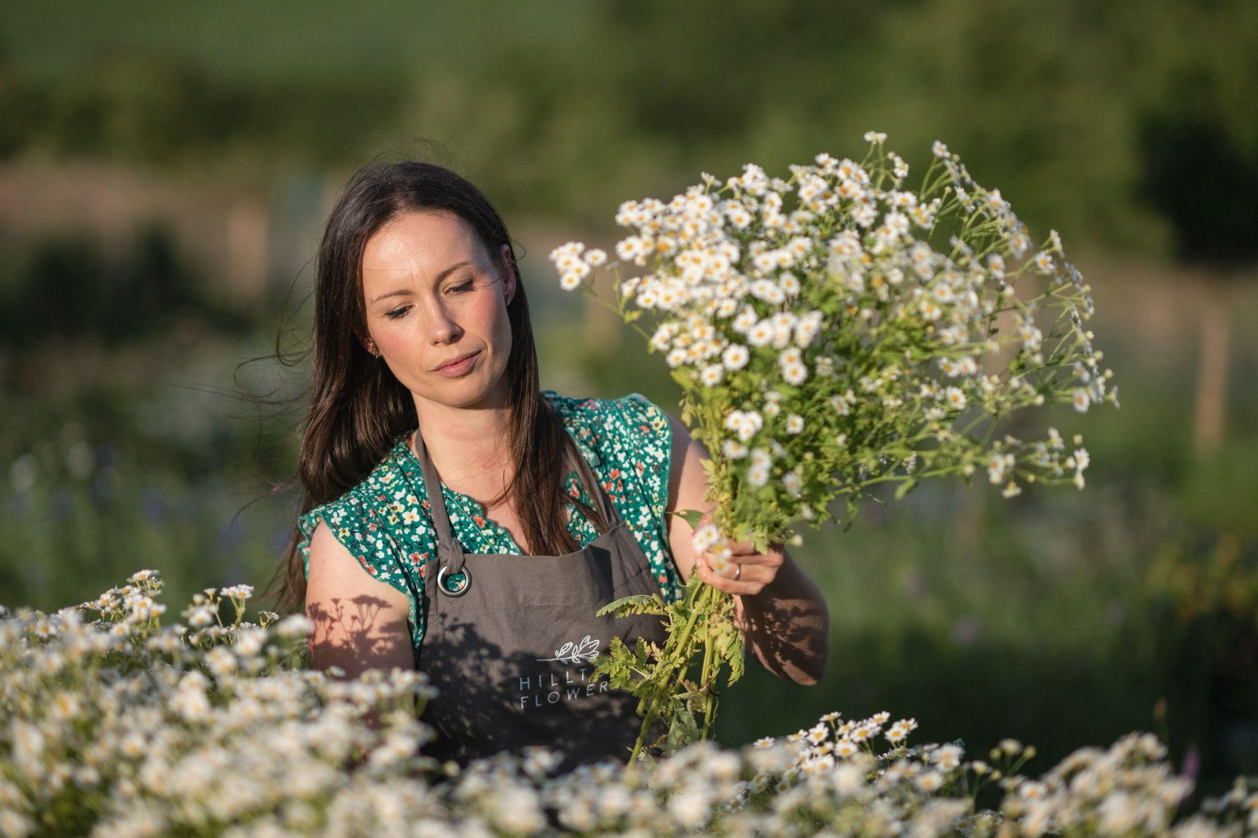

It’s @british.flowers.week from 15–21 June, and we’re thrilled to be taking part.

You can join us [insert event details here inc. name of event, date of event(s), locations, prices etc].

This annual celebration of British flowers is run by @flowersfromthefarm, who will be promoting other events throughout the week.

Find more information via: flowersfromthefarm.co.uk/british-flowers-week

📸 Image courtesy Hilltop Flowers

#BritishFlowersWeek2026

Other steps

- Hashtags for Instagram: #BritishFlowersWeek #BritishFlowersWeek2026
- Accounts to tag: @british.flowers.week and @flowersfromthefarm
Pre-prepared content
We welcome all members to support British Flowers Week. You might share your story, discuss your favourite British flower or promote an event that is part of the festival.

Some facts you may want to us include:

- 2026 is the UN’s International Year of the Woman Farmer, and the British flower industry is a fantastic example of this.

- Entrepreneurial women are at the forefront of the diverse UK flower growing sector, running successful businesses and promoting sustainable, agroecological growing practices.

- Data published by Flowers from the Farm shows that the British flower industry is growing and making a positive economic impact.

- Average yields jumped from 30,700 to 43,500 stems per hectare in the last year alone

- Average stems per member increasing by 55% to 32,500.

Below are image assets you are also welcome to use:
https://www.dropbox.com/scl/fo/oyeym8w25fw2fetxu4a0q/ALzqhTNul_V0DYWE0RrDQk4?rlkey=i2o1xec5rro99iv48g6b7wg5c&st=6ljmgh78&dl=0
Example content
Stuck for ideas? Good approaches include introducing your business, promoting your event or spotlighting your favourite flowers.

Introduce your business
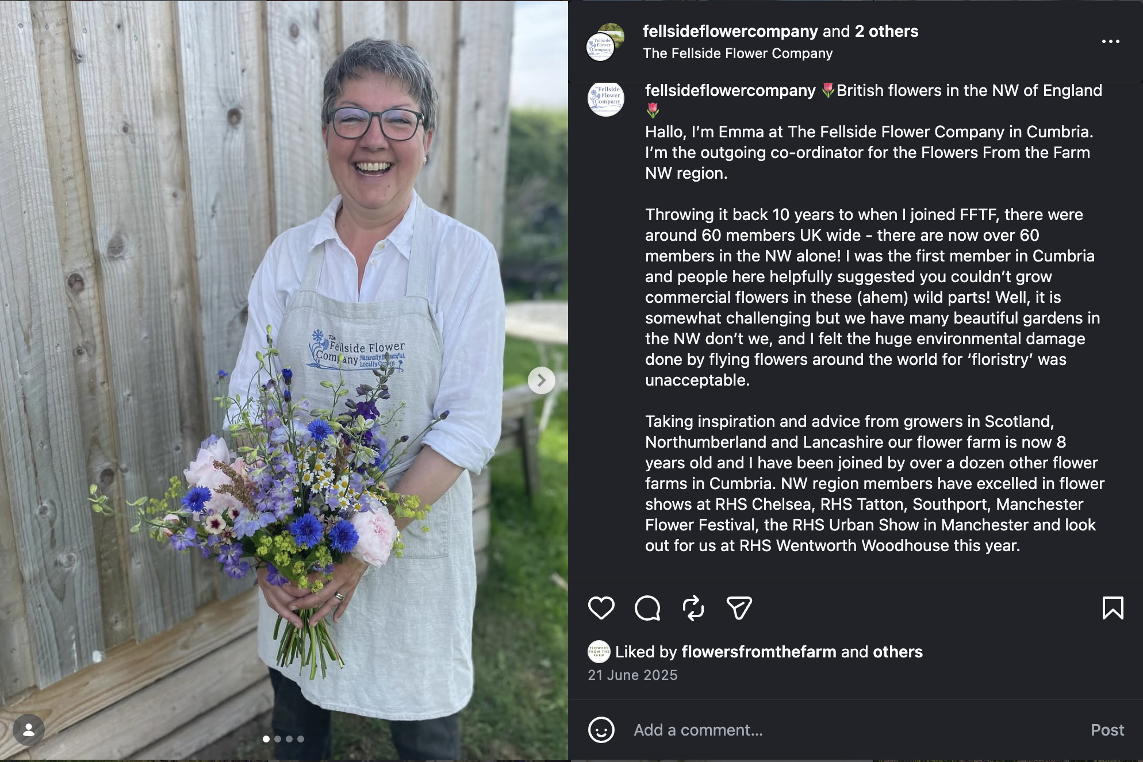
https://www.instagram.com/p/DLK87Zvtzuz/?img_index=1

Talk about your favourite flowers
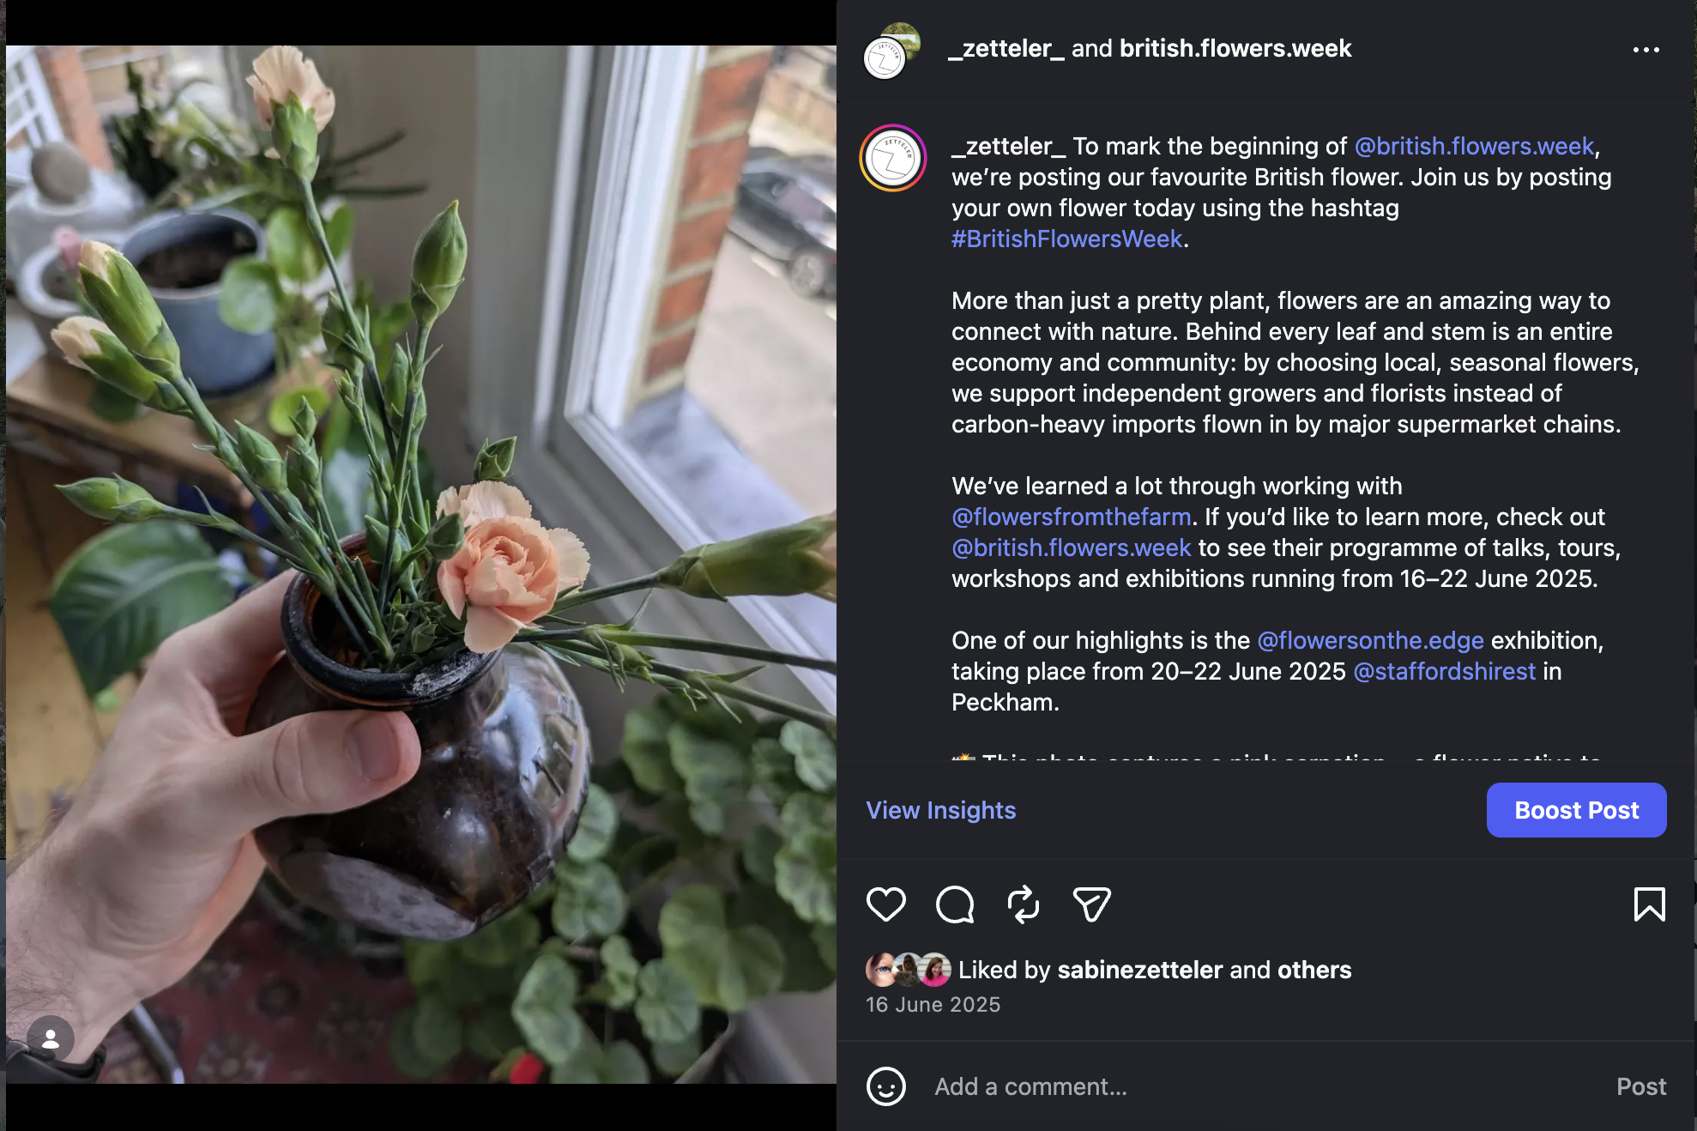
https://www.instagram.com/p/DK9upwCvsTk/

Highlight the use of flowers / materials
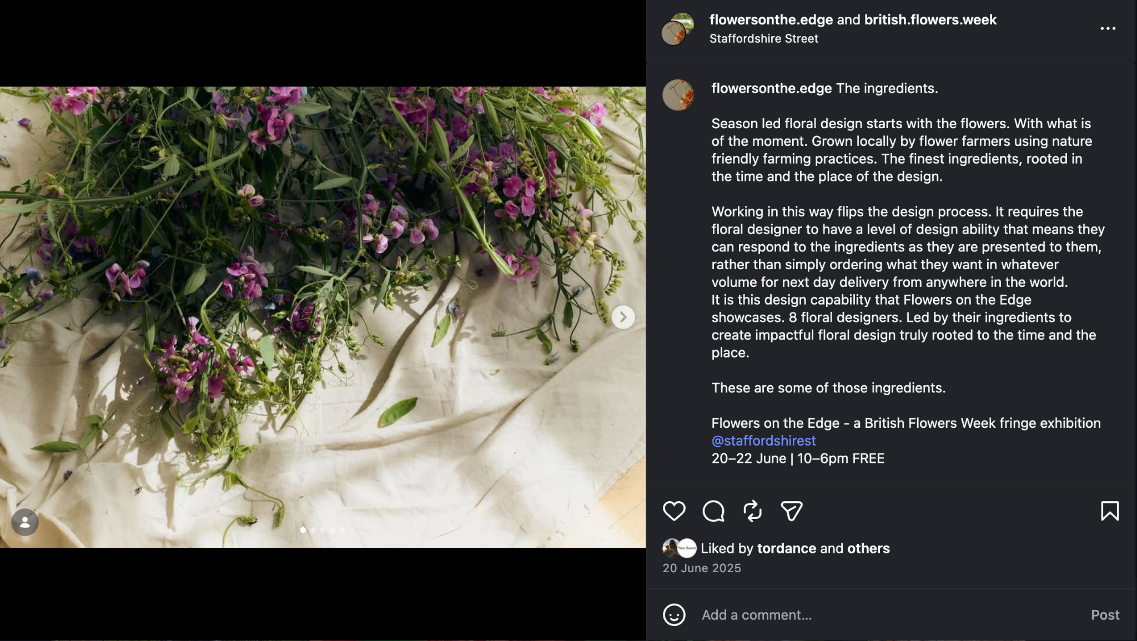
https://www.instagram.com/p/DLIX_WsNhFC/?img_index=1

Do a ‘day in the life’ video
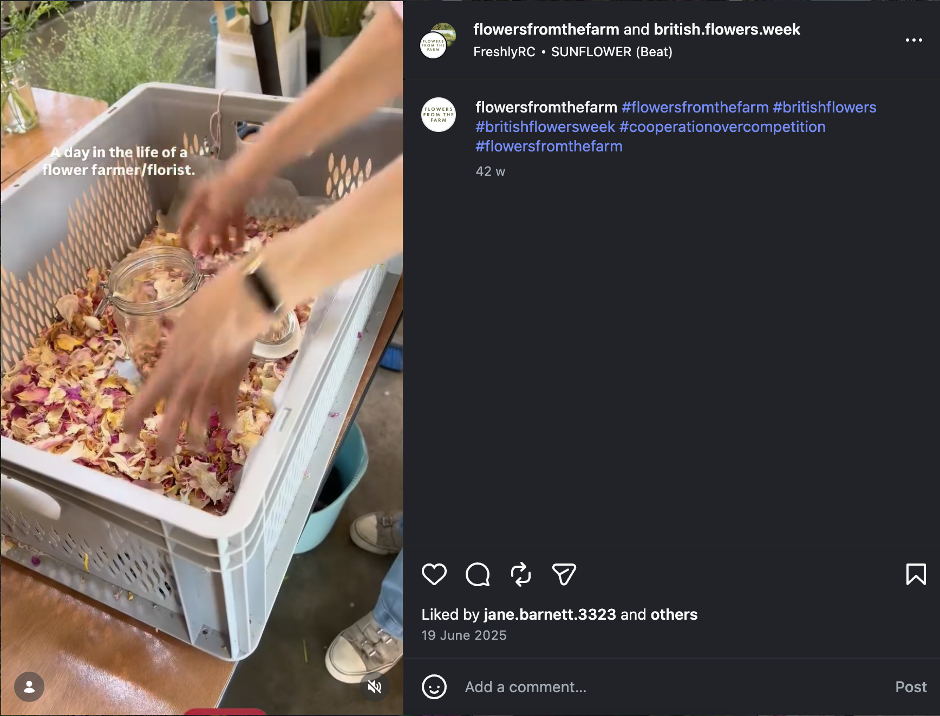
https://www.instagram.com/p/DLGQmM1Im7l/

